**TABLE OF CONTENT**

1.ServiceNow Platform

2.ServiceNow enterprise cloud

3.ServiceNow platform interface

4.users

5.groups

6.supported authentication

7.element of ServiceNow

8.version of ServiceNow

**ServiceNow platform:**

* ServiceNow is a American company which has a product called ServiceNow platform.
* This company are providing a application platform as a service and we called it has APAAS.
* They are many types of service like product as a service, application as a service etc..
* It’s a cloud based computing model which provide the infrastructure for the ServiceNow.

**ServiceNow enterprise cloud:**

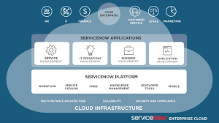

* The ServiceNow platform is a Application platform as a service.
* It is a single platform. Here, we can automate the business processes across the enterprise by providing the infrastructure
* It’s a single data model build on flexible schema.
* ServiceNow architecture is a multitenant architecture that can be access by any cloud system.

**ServiceNow Platform Interface:**

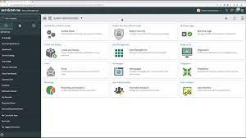

There are many way to interact with platform

The ServiceNow provide a three interface platform for interact the platform

1.user interface

2.user interface mobile application

3.advance user interface

**1.user interface:**

* Its also called as native user interface
* It’s the way to interact with application
* And its used for developing the application

**2.UI mobile application:**

* We can use the ServiceNow in mobile.
* Here, we can only access the limited module.

They are three types of mobile applications

1.serviceNow agent application:

2.Now mobile application

3.ServiceNow on boarding application

**3. Advance user interface:**

* The advace UI is also called a service portal.
* If the user has any issues means it raise the ticket and give the result for that ticket.

The ServiceNow consist of four category:

* Request something
* Knowledge base
* Get help report
* Community

**Users:**

* Within a ServiceNow instance,user are:
* Updating the records
* Importing data
* Requesting items
* Implementing flows
* Approving knowledge content
* Running reports
* Developing applications

**Groups:**

* A collection of user is called group.

Example of groups include:

* Service desk
* Knowledge base authors
* HR administrators

**Supported Authentication:**

* They are various method that the user can be authenticated. Including:
* Local database
* Multifactor
* LDAP
* SAML 2.0
* OAuth 2.0
* Digest Token

**Element of ServiceNow:**

The ServiceNow user interface is divided into three areas:

**1.Banner frame:**

The banner frame highlights important tools and setting that apply to your instance.

**2.Application Navigator:**

The components of the application navigator, the panel on the left side, are based upon your assigned role.

**3.Content Frame:**

The content frame display information such as lists, forms, dashboards, knowledge bases, abd service catalogs depending on where you navigate within the platform.

**Version of ServiceNow:**

* Ui16
* Ui15